HIGHLIGHTS FROM INTER HOUSE COMPETITIONS
INTER HOUSE BOARD DECORATION COMPETITION CONDUCTED ON 11 MAY 2022:

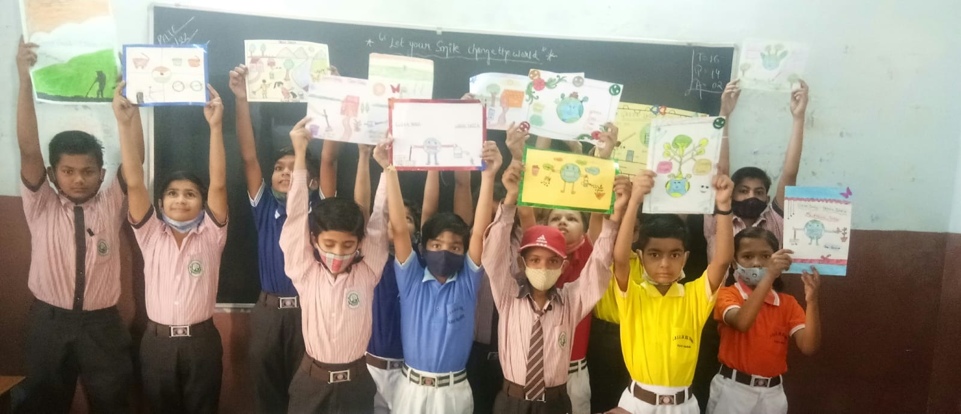
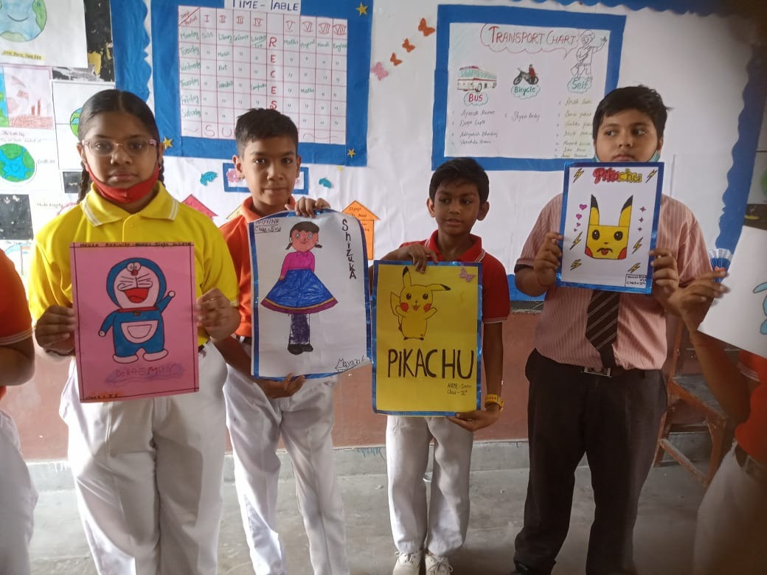
INTER HOUSE KALAMKARI ART COMPETITION:
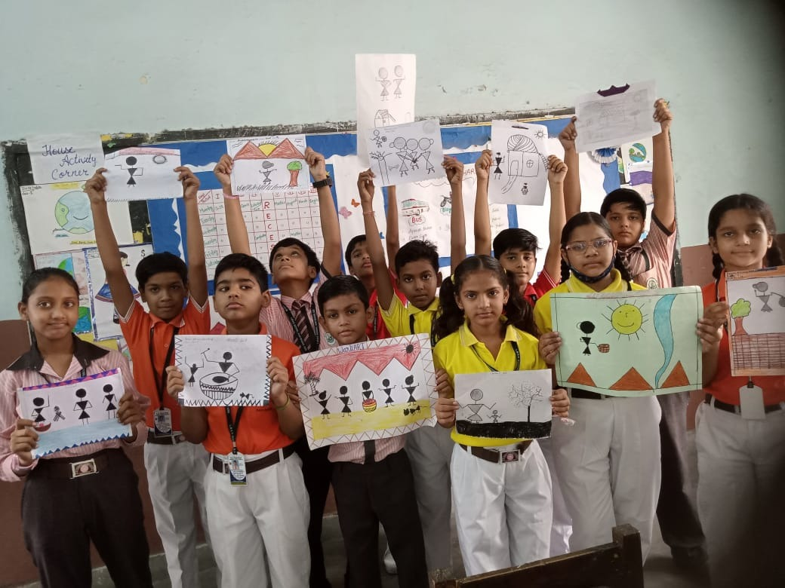

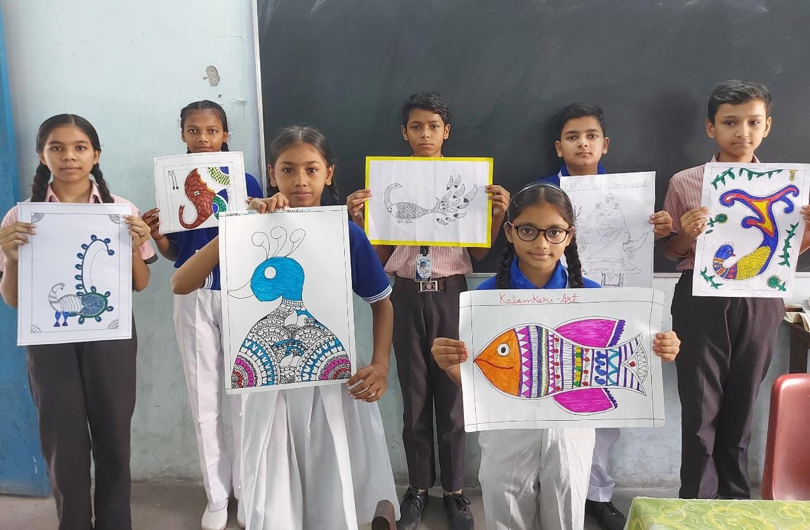
INTER HOUSE DIWALI DECORATION COMPETITION:
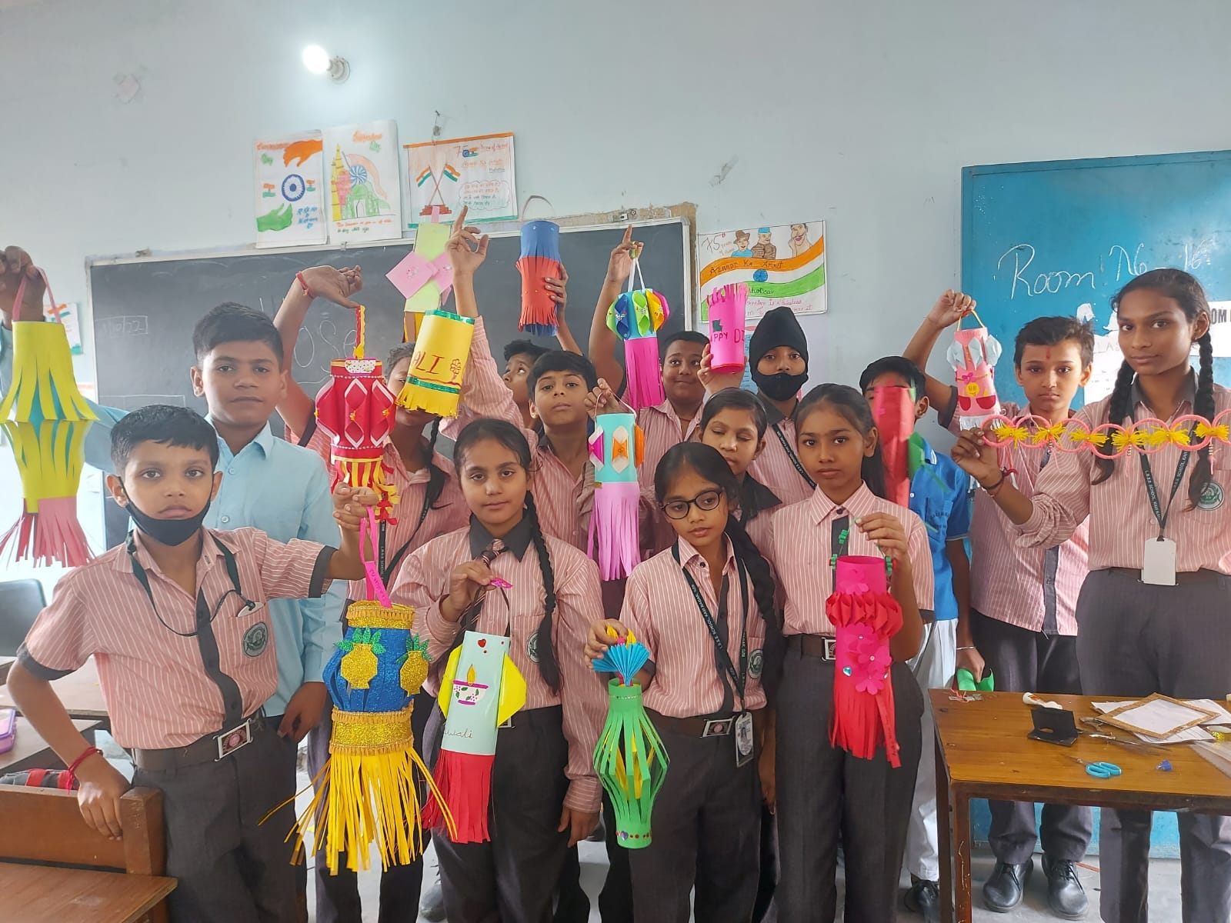

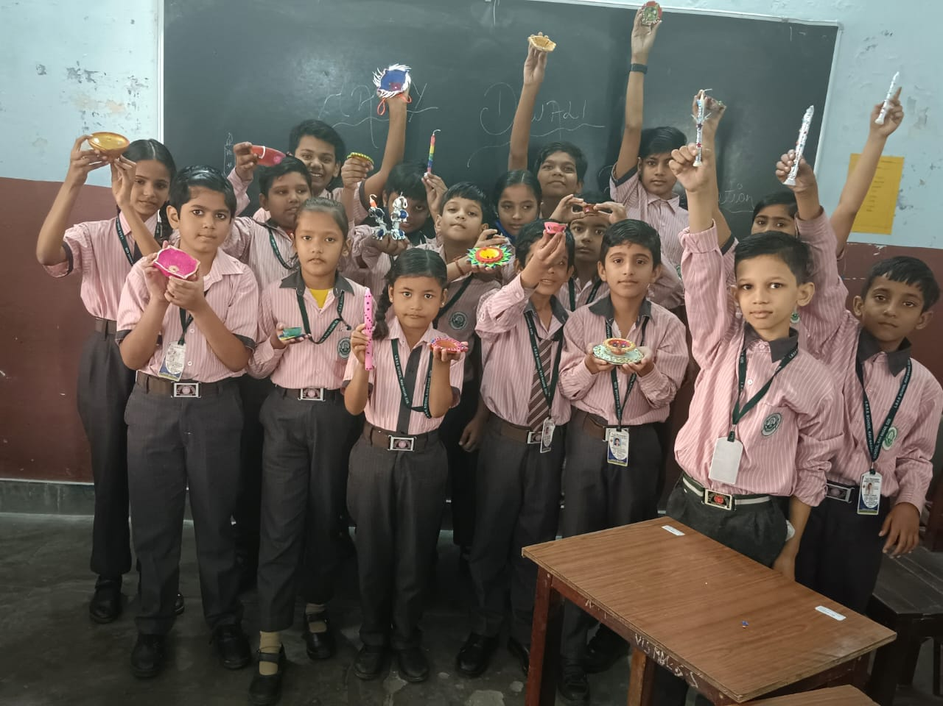
INTER HOUSE EXTEMPORE COMPETITION:
